To: All Universal Credit Portal Landlords
Date: 21st February 2024

What you need to tell us for the 2024 Annual Rent Change

You will need to complete a 'Confirm tenant's housing costs' to-do for your tenants who complete a 'Confirm your housing costs' to-do.
The tenant’s name, date of birth and address are displayed first.
The first question is ‘Is this person your tenant and liable for rent at this address?’. There are two radio button options: Yes and No.
If you choose No, you must answer 'Why have you said this is not your tenant?'. Explain why in the text box, then, select Continue.
If you choose Yes, select Continue, which takes you to the next page.
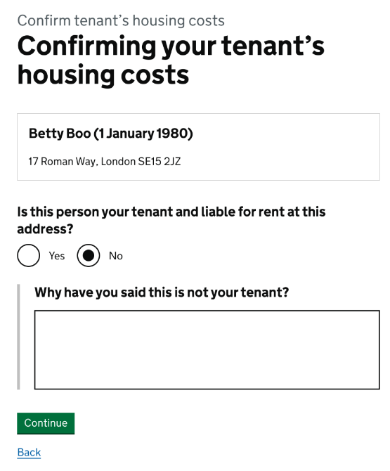

The tenant’s name, date of birth and address are displayed again.
Answer ‘How often do you charge rent?’ by choosing weekly, fortnightly, four weekly, monthly or quarterly from the dropdown menu.
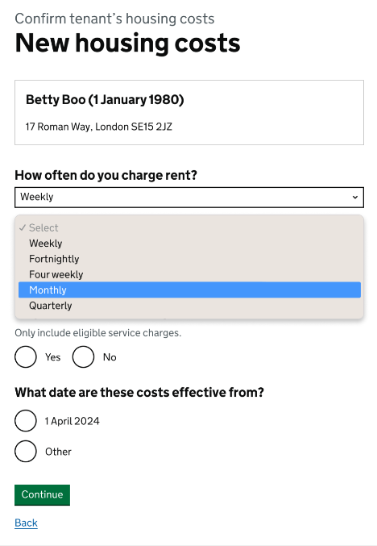
There is a numeric box for ‘What is the rent?’. Enter the amount without service charges or rent arrears.
Answer ‘Do you have service charges?’ by choosing from the Yes or No
radio buttons.
If you choose No, proceed to ‘What date are these costs effective from?’
If you choose Yes, answer the question ‘How often are the service charges?’ by selecting one of the following from the dropdown menu: weekly, fortnightly, four weekly, monthly or quarterly.
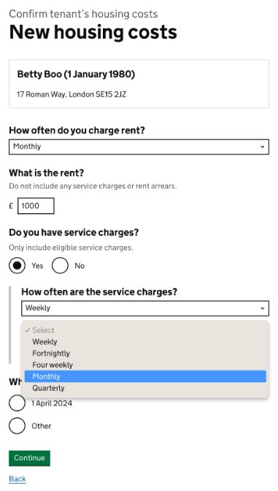
Answer ‘What are the available service charges?’ by entering the amount in the numeric box.
Answer ‘What date are these costs effective from?’ by choosing from the 1 April 2024 or Other radio buttons.
If you choose Other, complete the numeric boxes for Day, Month and Year with the date that the new costs came into effect.
If you choose 1 April 2024, select Continue.
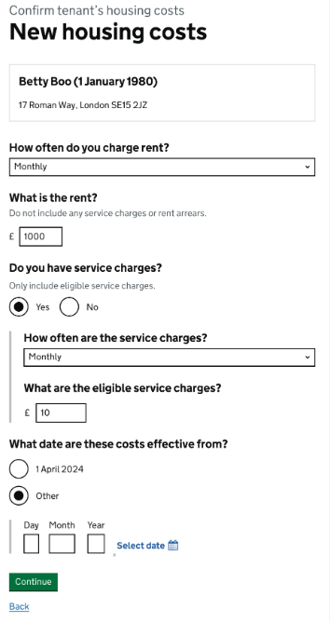

The final screen confirms the tenant’s information and the details of housing that you have provided:
- date of change
- rent
- eligible service charges (if applicable)
To correct any errors, use the ‘Change’ hyperlinks next to each detail.
If the details are correct, select Accept and send to submit the information.

Screen 3: Check new housing costs, accept & send
