Housing Benefit Circular
Department for Work and Pensions
Caxton House, Tothill Street, London SW1H 9NA
HB 12/2014
ADJUDICATION AND OPERATIONS CIRCULAR
WHO SHOULD READ | All Housing Benefit (HB) staff
ACTION | For information
SUBJECT | Universal Credit: Change of circumstances affecting Housing Benefit
Guidance Manual
The information in this circular affects the content of the HB Guidance Manual. Please annotate this circular number against paragraph 6.360 – Change of circumstances.
Queries
If you
- want extra copies of this circular/copies of previous circulars, they can be found on the website at https://www.gov.uk/government/collections/housing-benefit-for-local-authorities-circulars-2014
- have any queries about the
- technical content of this circular, contact
la.universalcredittransition@dwp.gsi.gov.uk
- distribution of this circular, contact
housing.correspondenceandpqs@dwp.gsi.gov.uk

Crown Copyright 2014
Recipients may freely reproduce this circular.

Universal Credit: Changes of circumstances affecting Housing Benefit
Contents page

Introduction 3
Background 3
Change of circumstances that affect HB 4
Universal Credit Migration Gather Proforma 4
Receiving and completing the UC MGP1 (LA) 5
Treatment of outstanding HB appeals – MGP2 6
Treatment of HB overpayments in Universal Credit 6
Further information 8
Annex A: Universal Credit eligibility criteria 9
Annex B: Universal Credit Migration Gather Proforma 1 (LA) 10
Annex C: LA action to complete UC MGP1 (LA) – Claimant information 12
Annex D: UC MGP 2 – Appeal outcome notification 14
Annex E: LA action to complete UC MGP 2 – Appeal outcome notification 15

Universal Credit: Change of circumstances affecting Housing Benefit

Introduction

- This circular has been produced to guide local authority (LA) Housing Benefit (HB) teams through the actions to take if a Universal Credit claimant and a HB claimant have a change of circumstance that requires the closure of a HB claim.

- Since April 2013 Universal Credit has gone live across four areas in the north-west and six areas across the United Kingdom (UK). For LAs that are not within the Universal Credit ‘live’ areas, we recognise that as the service continues to expand and greater volumes are supported we will begin to see an increase in numbers of Universal Credit claimants moving out of ‘live’ areas into areas that are not yet live. We do not expect large numbers; however, the purpose of this circular is to set out the arrangements in place.

Background

- Universal Credit is a new, simpler, single monthly payment for working age people in work or out of work, which replaces:

- Income based Jobseekers’ Allowance
- Income related Employment and Support Allowance
- Income Support
- Child Tax Credits
- Working Tax Credits, and
- Housing Benefit

- Claimants currently receiving the above benefits will remain on them until such time that their claim is migrated to Universal Credit. These benefits will be referred to as legacy benefits.

- Universal Credit was first introduced in four locations in north-west England beginning April 2013. It was then introduced gradually across the rest of the UK, with six more locations taking Universal Credit claims between October 2013 and April 2014. The planned intention is for Universal Credit to expand the rest of north-west England starting in summer 2014, and to make Universal Credit available in each part of Great Britain during 2016. New claims to existing benefits, which Universal Credit is replacing, will then close down, with the vast majority of claimants moving onto Universal Credit during 2016 and 2017.

- The current Universal Credit eligibility criteria is summarised below, with full details at Annex A:

- New claim
- Single (in summer 2014, Universal Credit will start to progressively take claims from couples and, in the autumn, from families).
- Fit for work
- With no children
- With or without housing costs (but not mortgages)
- No savings over £6000

Change of circumstances that affect HB

- Once a claimant is in receipt of Universal Credit they will remain on Universal Credit even if their circumstances change (subject to conditions of entitlement), for instance if they gain a partner or children, or move away from the Universal Credit area.

- As the likelihood of a Universal Credit claimant moving out of a ‘live’ area increases, LAs may find it useful to include the question “have you claimed Universal Credit?” on HB claim forms.

- If you identify a Universal Credit claimant the initial action on the LA should be to direct the claimant to the Universal Credit Service Centre phone line on 0845 6000 723 or text phone 0845 600 0743 to report their change of circumstance. Claimants are advised not to email the Universal Credit Service Centre as this may delay their claim.

- If the Universal Credit claimant becomes part of a couple, living in the same household, then the joining partner (known as the ‘New Claimant Partner’) will become part of the existing Universal Credit claim (subject to conditions of entitlement) and the couple will receive one monthly payment. If the new claimant partner is receiving any of the benefits listed in paragraph 3 then those awards must be terminated.

- This means that an LA outside the Universal Credit area will normally be required to close down a HB claim if:

- HB claimant leaves the accommodation for which HB is paid, to move in with a Universal Credit claimant, or
- Universal Credit claimant moves out of the Universal Credit area and into accommodation with an existing HB claimant

- When a change of circumstance is reported to Universal Credit to add a new claimant partner to a Universal Credit claim, the Universal Credit agent will check the Customer Information System (CIS) to establish if there is any legacy Department for Work and Pensions (DWP), HM Revenues and Customs or LA benefits. When necessary, a Universal Credit agent will contact the LA of the new claimant partner to initiate the migration process of the HB claim to Universal Credit.

Universal Credit Migration Gather Proforma

- The Universal Credit Migration Gather Proforma 1 LA (UC MGP1 (LA)), at Annex B, is the form used by Universal Credit to request the LA carry out certain actions and provide information on a HB claimant who is migrating to an existing Universal Credit claim.

- The purpose of the UC MGP1 (LA) is for :

- Universal Credit to notify the LA that the HB claim should be closed to prevent dual provision of benefits
- the LA to provide information on the new claimant partner that is not visible to DWP and which may affect the Universal Credit claim

Receiving and completing the UC MGP1 (LA)

- The Universal Credit agent will telephone the LA HB team to be alert that the UC MGP1 (LA) will be sent by email, and to take the secure email (GSx/GCSx) address to send the form to. The LA should complete the UC MGP1 (LA) and return it to the Universal Credit Service Centre via secure email.

- In 2013 all LAs were requested to set up a secure generic email address for their correspondence with Universal Credit. If your LA has not yet set up a secure mailbox please contact LA-SST.HDD@DWP.GSI.GOV.UK to organise this.

- In order for Universal Credit to take the required action on the Universal Credit claim, LAs are requested to return the completed UC MGP1 (LA) within 5 working days of receipt. Or if it is not possible to meet the timeframe, LAs should contact the Universal Credit Service Centre on 0845 6000 723.

- Not returning the completed UC MGP1 (LA) within 5 days may result in an incorrect Universal Credit award, which could have serious consequences for the claimant meeting their financial commitments. This could also impact the LA with regards to any overpayment of HB, which would have subsidy implications if the overpayment did not satisfy the criteria for classification as departmental error. HB overpayments in Universal Credit are covered in paragraphs 23 to 29.

- The Universal Credit Agent completes the first part of the UC MGP1 (LA), which covers:

- Claimant details - this will be the HB claimants details
- Universal Credit effective date
- Benefit(s) in payment

- The LA should complete all relevant fields of the second part of the UC MGP1 (LA), which provides information on:

- HB closure
- Debt
- Sanctions

- Detailed guidance on completing the UC MGP1 (LA) is set out at Annex C.

- If the HB claimant queries the LA about entitlement to Universal Credit or the process to claim Universal Credit, the LA should direct the claimant to ring the Universal Credit Service Centre on 0845 600 0723 or text phone 0845 600 0743.

Treatment of outstanding HB appeals – MGP2

- If after the claimant has migrated to Universal Credit, the LA receives a decision on an outstanding appeal for the claimant, they should notify Universal Credit of the outcome by completing form MGP2 set out at Annex D. Guidance on how to complete the MGP2 is set out at Annex E.

Treatment of HB overpayments in Universal Credit

The Universal Credit (Transitional Provisions) Regulations 2014: provision for New Claimant Partners who had been receiving Universal Credit

- Paragraphs 24 to 29 of Adjudication and Operations Circular A13/2013 advised on the treatment of an overpayment that might arise when a person moves out of the home for which they had been awarded HB in order to move in with a Universal Credit claimant as their partner (a ‘New Claimant Partner’).
- Because of the whole month approach that Universal Credit applies, and the operation of The Universal Credit (Transitional Provisions) Regulations 2013 (SI 2013/386), it is possible that an overpayment might be created for a period when the person still has a genuine liability for the rent on the home they have vacated.
Example
11th
31st
1st
Chris living alone
Chris has moved into Nick’s home
UC is payable for Nick’s accommodation for whole month, but not for Chris’s former home
First assessment period for Chris and Nick’s joint UC claim
Scenario 1: Chris is claiming HB, and moves in with Nick, a UC claimant, as a new claimant partner on 11 February. Nick has a UC assessment period running from 1st to 31st of the month.
- Paragraph 27 stated that we were reviewing the operation of the regulations in this regard, because the fact that they would not receive Universal Credit housing element in respect of the liability either meant that there could be a gap in support. We have now included provision in The Universal Credit (Transitional Provisions) Regulations 2014 (SI 2014/1230) to address this, subject to Parliamentary approval, from 16 June 2014.
- Regulation 7(5) of the new transitional regulations states that:
“(5) An award of Housing Benefit to which the New Claimant Partner is entitled does not terminate by virtue of this regulation where
(a) the award is in respect of exempt accommodation; or
(b) the New Claimant Partner leaves the accommodation in respect of which Housing Benefit was paid, in order to live with A.”
[‘A’ being the Universal Credit claimant]
- The effect of Regulation 7(5)(b) is that, from 16 June, HB can be paid according to the HB Regulations, so that the New Claimant Partner will not experience any gap in housing support for the property they are leaving, and no overpayment will be created.
Example
11th
31st
1st
Chris living alone
Chris has moved into Nick’s home
HB payable until Sunday after Chris moves out
First assessment period for Chris and Nick’s joint Universal Credit claim
Scenario 1: Chris is claiming HB, and moves in with Nick, a Universal Credit claimant, as a new claimant partner on 11 February. Nick has a Universal Credit assessment period running from 1st to 31st of the month.
Universal Credit is payable for Nick’s accommodation for whole month
16th
- This provision will not apply to cases where it is the Universal Credit claimant who moves into the property of the New Claimant Partner. In these cases, the HB award will still end on the day before the first date of Universal Credit entitlement, because the new joint Universal Credit award will include a housing element for that property for the full period.
Example
11th
31st
1st
Chris living alone
Nick has moved into Chris’s home
Universal Credit housing element payable for whole month for accommodation for which Chris was getting HB
First assessment period for Chris and Nick’s joint Universal Credit claim
Scenario 2: Nick, who receives Universal Credit, moves in with Chris, who has been getting HB, on 11 February. Nick has a Universal Credit assessment period running from 1st to 31st of the month.

Further information

- If you have specific questions about the process to follow after receiving the Universal C MGP1 (LA) or the MGP2, contact the Universal Credit Service Centre on 0845 6000 723 or email LA-SST.HDD@DWP.GSI.GOV.UK. Please do not give claimants this email address, as if claimants email rather than phone it may delay their claim.

Annex A: Universal Credit current eligibility criteria

The scope for claimant inclusion in Universal Credit is set out below. Eligibility is restricted in line with the expansion in scope and scale of Universal Credit over the next 2 years. Universal Credit is now live in 10 areas across the country. This summer, Universal Credit will start to expand to cover more of the north-west. The 10 live areas will expand beyond the existing single claimant group, to new claims from couples and families at a date to be confirmed later in 2014.

1. Where does the claimant live - This only applies to specific post code served by Jobcentres delivering Universal Credit from October 2013. Claimants living outside of the specified post code areas cannot claim Universal Credit.

- Personal Circumstances - To claim Universal Credit the claimant currently must:
be single | not be pregnant
be a Great Britain national and normally resident in Great Britain | not have given birth within the last 15 weeks
have a valid National Insurance number (NINO) (excludes  temporary NINOs) | not have responsibility for children (including adopted or foster children) or provide care for any other person
be between 18 years old and 60 years  and six months | not be a registered foster parent (even if no child is currently placed with them)
have a bank or building society account  or Post Office Card Account | not be required by the Child Maintenance Enforcement Commission (CMEC) to pay child maintenance
not be homeless or in supported accommodation | not have a fit note (unless Work Capability Assessment [WCA] confirmed found fit for work)
not own their own home (including  part ownership) | not be in a period of self-certification awaiting a fit note
not have more than £6000 in Savings  and Capital | not be making the claim through a Personal Acting Body (PAB)/Corporate Acting Body (CAB)
not have a family member in the Armed Forces
who is away in connection with those duties

3. Current Benefit Status - A claim to Universal Credit cannot be made if the claimant is in supported or exempt accommodation, or is entitled to or waiting to hear about a claim to or is waiting to hear about an Appeal or Reconsideration for any of the following benefits:
Jobseeker’s Allowance (JSA)* | Working Tax Credit
Employment Support Allowance (ESA)** | Child Tax Credit
Income Support (IS) | Housing Benefit
Incapacity Benefit
* For JSA only, the claimant must also have left old style JSA more than two weeks ago to claim Universal Credit during Pathfinder. **Has not had an ESA (Contribution Based) claim ended in the last two weeks unless found fit for work

Disability Benefits - To claim Universal Credit the claimant must not be entitled to Disability Living Allowance, Personal Independence Payment or Carers Allowance.

4. Employment/Education status - To claim Universal Credit the claimant must declare they are / will:
not expect any self employed earnings in the next month
not be in any form of education or training
not expect to commence education or training in the next month
Be out of work or in work but does not expect to have net earnings (from employment) in the next month exceeding:
- Single claimant <25 = £270 | - Single claimant >25 = £330

Annex B: Universal Credit Migration Gather Proforma 1 (LA)

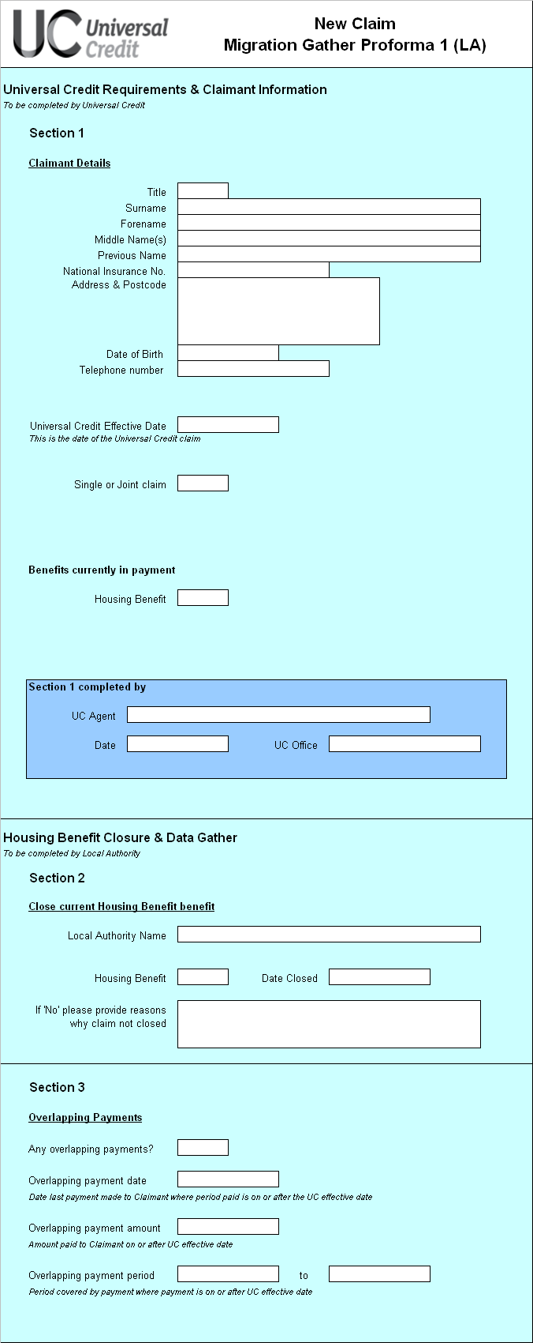
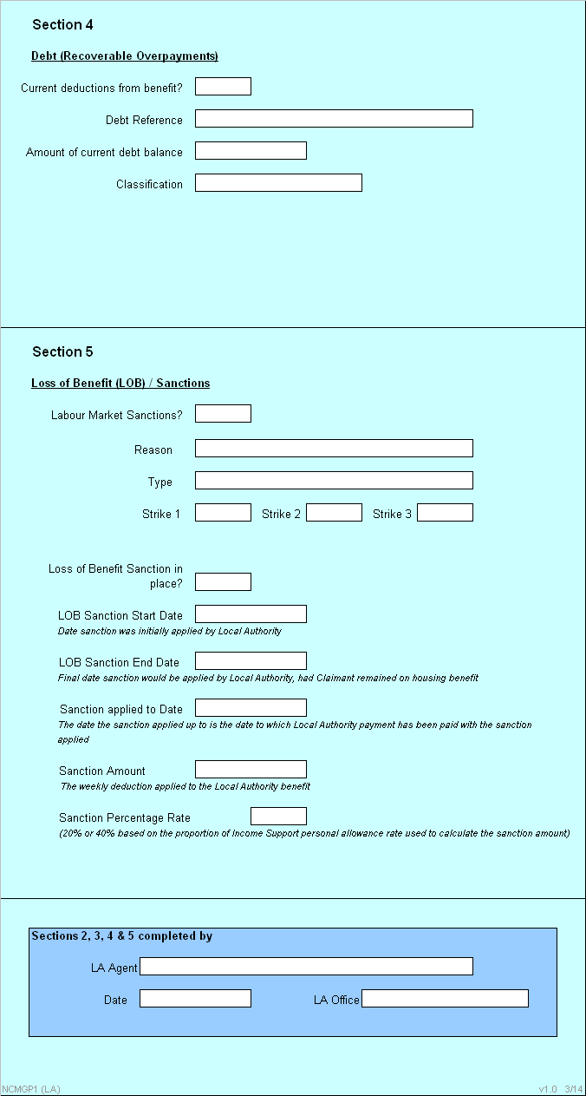

Annex C: LA action to complete UC MGP1 (LA) – Claimant information

STEP | ACTION | NOTES
1 | Access LA Mailbox and open the UC MGP1 (LA) email and attachment | Section 1 will have been pre-populated with the claimants details by the Universal Credit agent
2 | Check UC MGP1 (LA) to see if closure action is required on HB, and action as required. | Business As Usual – follow current LA guidance for closure of HB.  Note: HB entitlement will end the day before the 1st date of the existing claimants assessment period regardless of when in the month the couple form
3 | Check for current Deductions
4 | Check Legacy system (s) for current debt deductions.  If there are no current debt deductions, tick the ‘No’ box and go to step 7 | Business As Usual – follow current LA guidance to access systems/records and check for current debt deductions.  Only consider HB related debt currently being recovered by deduction from HB.  Note: Only the joining partner’s debt will be considered
5 | Identify current debt. | Debt classifications: HB Fraud overpayments and recoverable HB overpayments. Only the above debt types are to be considered for recovery by Universal Credit.  Note: If joining partner was part of a previous joint HB claim, LAs to use own Business As Usual rules to apportion relevant amount of debt to joining partner.
6 | Update Debt Section of UC MGP1 (LA) with current debt deduction details | If current debt deductions exist, the following information will need to be provided: debt reference, amount outstanding, date of decision, classification.
7 | Check for Sanctions
8 | Check Legacy system (s) for Sanctions.  If NO sanctions exist tick the ‘No’ box and go to Step 11 | Business As Usual – follow current LA guidance to access systems/records and check for current sanctions.  Only check for Loss of Benefit Sanctions that have not expired before the Universal Credit Effective Date
9 | Identify Sanction migration details | For LAs, the Sanction Reason is the justification for applying the sanction.  For LAs, the only applicable Sanction Type is Loss of Benefit (due to fraud).  Sanction Sub-type for a Loss of Benefit sanction is either, Strike One, Two or Three.  Sanction Period (start date) is the first date the Loss of Benefit sanction was applied to the Legacy organisation.  Sanction Period (end date) is the date the Loss of Benefit sanction would be applied by the Legacy organisation, if the Claimant had remained on Legacy Benefit.  Date Sanction Applied Up To is the date to which Legacy Benefit payment has been paid to with the Sanction applied.  Sanction Amount is the weekly reduction (£s) applied to Legacy Benefit.  Sanction Percentage Rate is 20% or 40% (based on the proportion of the IS Personal Allowance Rate used to calculate the Sanction Amount).
10 | Update UC MGP1 (LA) with sanctions to be migrated to Universal Credit | Update the UC MGP1 (LA) with details of each sanction to be migrated to Universal Credit
11 | Sign UC MGP 1 (LA)
12 | Create email message(s) and attach completed UC MGP1 (LA) | From: LA secure mailbox – add own LA address  To: Universal Credit Mailbox  Subject: Universal Credit MGP1, Expiry Date, NINO, Surname, Initial, RESTRICTED  Email Body: Attach completed UC MGP 1 (LA)
13 | END

Annex D: UC MGP 2 – Appeal outcome notification

Annex E: LA action to complete UC MGP 2 – Appeal outcome notification

The outcome of an appeal against a legacy benefit decision may be notified after the claimant has been included on a Universal Credit claim.

The LA agent establishes the claimant’s ‘Universal Credit Effective Date’ (using CIS or the MPG1). The LA checks if the period covered by the appeal is within 1 calendar month of this.

If the period of the appeal is within 1 month of the ‘Universal Credit Effective Date’ the LA agent must complete an MGP2 form, which must show:

- NINo , name and date of birth of the claimant
- Appeal outcome – Upheld/Disallowed
- Type of Appeal
- Effect of Appeal decision on Legacy Benefit
- Appeal start date
- Appeal end date
- name, phone number and team of the person who completes the form

The LA agent sends the form as an attachment in the format:

- From: LA designated GSx/GCSx account
- To: Universal Credit Mailbox
- Subject: UC MGP 2, NINO, Surname, Initial, RESTRICTED
- Email Body: Attach the completed UC MGP 2

