Confirm Your Housing Cost To-Do screens

1

The Confirm your Housing Costs To-do will be in your To-do list on your Universal Credit account

2
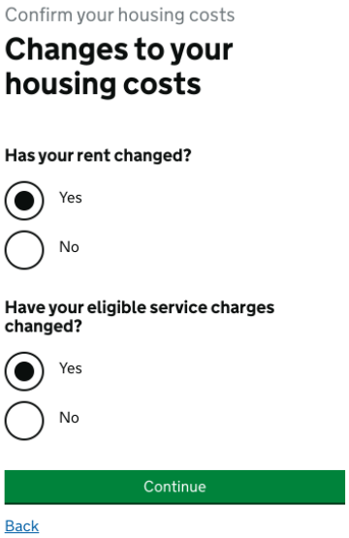
Select yes to say your rent and service charges (if you have them) have changed

3
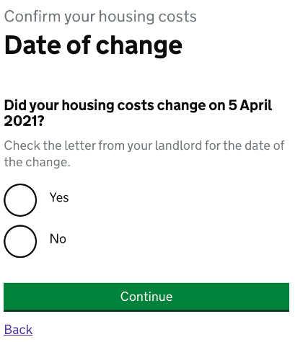
You need to select yes to say your rent changed from 5 April 2021
4
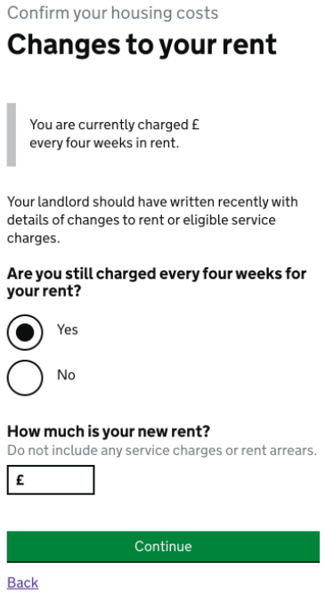
Enter the 4 weekly rent amount from your rent letter

Select Yes

The Universal Credit system will display the current rent held on your account

5
If you currently have Service Charges recorded on your Universal Credit Housing Costs you will be taken to the following screen:

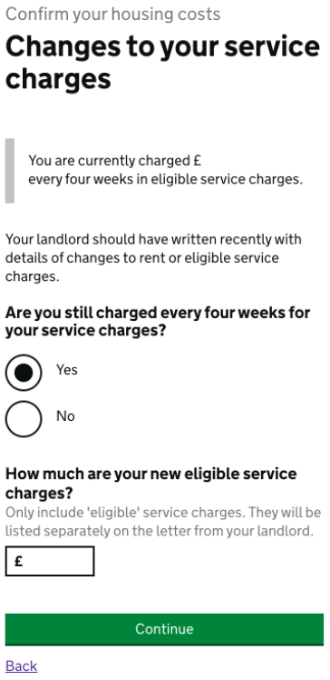
The Universal Credit system will display the current service charges held on your account
Enter the 4 weekly eligible service charge amount from your rent letter

Select Yes

6
Once you have answered these questions you will see a summary of your answers. If you have made any mistakes you can change your answers.

If you are happy with the information you have provided press confirm to complete the To-Do.

